|  |
| --- |
| Name:  **T S S C Silva** |
| Student Reference Number:  **10673869** |



|  |  |  |
| --- | --- | --- |
| Module Code: **CNET237SL** | Module Name: **Computer Network** | |
| Coursework Title: **System of the Supermarket chain** | | |
| Deadline Date: **16/05/2020** | | Member of staff responsible for coursework:  **Mr. Chaminda Attanayaka** |
| Programme: BSc. (Hons) Computer Security, BSc. (Hons) Computer Network | | |
| Please note that University Academic Regulations are available under Rules and Regulations on the University website [www.plymouth.ac.uk/studenthandbook](http://www.plymouth.ac.uk/studenthandbook). | | |
| Group work: please list all names of all participants formally associated with this work and state whether the work was undertaken alone or as part of a team. Please note you may be required to identify individual responsibility for component parts.  **10679384 - Introduction, Network Technology that are used**  **10673866 - Specification of Equipment that used, Equipment of the Network**  **10673872 – Assumptions, Internet protocol address**  **10673882 - Network Plan of the Supermarket, References**  **10673869 – Plan of the Network**  **10673856 – Subnet, Bills of Materials**  ***We confirm that we have read and understood the Plymouth University regulations relating to Assessment Offences and that we are aware of the possible penalties for any breach of these regulations. We confirm that this is the independent work of the group.***  Signed on behalf of the group: | | |
| Individual assignment: ***I confirm that I have read and understood the Plymouth University regulations relating to Assessment Offences and that I am aware of the possible penalties for any breach of these regulations. I confirm that this is my own independent work.***  Signed: | | |
| Use of translation software: failure to declare that translation software or a similar writing aid has been used will be treated as an assessment offence.  I *have ~~used~~/not used translation software.  If used, please state name of software………………………………………………………………… | | |
| **Overall mark _____% Assessors Initials ______ Date_________** | | |

*Please delete as appropriateSci/ps/d:/students/cwkfrontcover/2013/14



**CNET237SL Computer Networks**

**Complete Network Report**

**Group No: Team 02**

**Members:**

|  |  |  |  |
| --- | --- | --- | --- |
| **Plymouth ID** | **Student Name** | **Degree Program** | **Contribution** |
| 10679384 | B D Geekiyanage | CS | Introduction  Network Technology that are used |
| 10673866 | R G M N S Rajapaksha | CS | Specification of Equipment that used  Equipment of the Network |
| 10673872 | T N Thewarapperuma | CS | Assumptions  Internet protocol address |
| 10673882 | U D S Deshan | CN | Network Plan of the Super Market  References |
| 10673869 | T S S C Silva | **CS** | Plan of the Network |
| 10673856 | S S Liyanage | CS | Subnet  Bills of Materials |

**MAY 2020.**

**Table of Contents**

**01** **Introduction.** 7

**02** **Network Topology that are Used.** 8

**02.1** **VPN Topology that Used to Create the System.** 10

**02.2** **LAN Topology that Used to Create the System.** 10

**03** **Assumptions.** 11

**03.1** **Supermarket Head Office.** 11

**03.2** **Supermarket Outlet.** 13

**03.3** **Supermarket Regional Centre.** 15

**04** **Plan of The Network.** 16

**04.1** **Physical Diagram of Head Office.** 17

**04.2** **Logical Diagram of Head Office.** 18

**04.3** **Physical Diagram of Outlet.** 19

**04.4** **Logical Diagram of Outlet.** 20

**04.5** **Physical Diagram of Reginal Distribution Centre.** 21

**04.6** **Logical Diagram of Reginal Distribution Centre.** 22

**04.7** **Packet Tracer Implementation of Outlet.** 23

**05** **Equipment for The Network.** 24

**05.1** **Primary Option.** 24

**05.2** **Secondary Option.** 25

**06** **Specification of Equipment that Used.** 26

**07** **Network Plan of the Super Market.** 29

**07.1** **Head Office.** 29

**07.2** **Super Market Outlet.** 29

**07.3** **Reginal Distribution Centre.** 30

**08** **Internet Protocol Address.** 31

**09** **Subnet.** 33

**10** **Bill of Materials.** 34

**10.1** **Primary Option.** 34

**10.2** **Secondary Option.** 35

**11** **Reference.** 36

**Acknowledgement.**

In performing out our errand, we expected to take the help and rule of some respected individuals who merit our most conspicuous appreciation. The finish of this errand gives us much happiness.

We should exhibit our gratefulness to Mr. Chamindara Attanayake sir for giving us each point from the soonest beginning stage till closure our task. We may similarly need to develop our most significant gratefulness to every single one of the people who have genuinely and in an indirect manner helped us in completing the errand.

A few people uncommonly our associates and partners itself, have offered significant comments and proposals on this recommendation which gave us an inspiration to improve our endeavor.

# **Introduction.**

As says in the scenario one of the most important organization bind is expected to actualize a system network and an arrangement all together make their business exceptionally powerful, proficient and furthermore strong where it contains up to five sub classes. And furthermore, they are giving principle openings where they have given store shopping to the individuals who are eager to go out on the town to shop as normal customary clients while they give internet shopping to the more youthful new ages by thinking about the restricted and important time of the clients. In like manner, the products or the things that has been bought by the clients online will be conveyed to their individual residencies or they will have the option to pick their things all alone at the closest market. As it has groups of business sectors all around the nation the requests that has been made by the clients must convey in to their closest areas as it will be simple and helpful for the conveyance of the products. Moreover, if any client needs to get their requests through any sort of Delivery Company for a case like dispatch administration, each time after they pick the client arranges so as to convey them to the separate areas, a message will be sent to the specific client and furthermore the client can pick whether to get the request or not and on the off chance that the pickup affirmed, at that point another message will remain referred toward the customer where it ensures the security of the client items and to keep up the reliable between the client and the organization. By executing this network, the principle network will be facilitated at the administrative center while the various sub chains will be associated with this primary network through a virtual private system. And this network for the installment technique, the center arrangement will have the specific application and it will assist with ensuring the protected connection with the bank to do the installment procedure. While the site that is required for the internet shopping models, individual online areas front end just as the messages are likewise facilitated at the ISP datacenter.

In addition, the application that has been made for the internet shopping process must be subject to PHP and MYSQL where focal validation network must utilize MS AD and for the administration on the system must utilize DNS, NTP, and DHCP. And this network to ensure the security and the insurance of the entire network must utilize an open source firewall.

# **Network Topology that are Used.**

**What is a topology?**

System topology alludes to how various focuses, devices, and relationship on your framework are really or authentically engineered by each other. Consider your framework a city, and the topology as the guide. Essentially, as there are various ways to deal with brains and keep up a city, for instance, guaranteeing the streets and roads can empower passage between the bits of town getting the most traffic there are a couple of various approaches to set up a framework. Each ha focal points and obstructions and depending upon the prerequisites of your association, certain blueprints can give you an increasingly conspicuous degree of accessibility and security. Alsop, these physical topology type has barely any customary topologies that can be named as follows,

* **Star Topology:** A star topology, the most broadly perceived system topology, is spread out so every middle in the framework is honestly connected with one central place point by methods for coaxial, twisted pair, or fiber-optic connection. Going about as a server, this central center point manages data transmission as information sent from any center point on the framework needs to experience the central one to show up at its objective and limits as a repeater, which thwarts data disaster.
* **Bus Topology:** A transport topology arranges all the gadgets on a framework along a single connection running a lone path starting with one completion of the framework then onto the next which is the explanation it's sometimes called a "line topology" or "Backbone topology."
* **Ring Topology:** Since each device is simply connected with the ones on either side, when data is transmitted, the packages moreover travel along the drift, going through all of the midway communities until they appear at their objective. In case a gigantic framework is organized in a ring topology, repeaters can be used to ensure wraps show up adequately and without data adversity. Only one spot on the systems permitted to send data immediately, which colossally reduces the peril of package impacts, making ring topologies compelling at transmitting data without botches.
* **Tree Topology:** The tree topology structure gets its name from how the central community fills in as a sort of stem for the system, with center points expanding outward in a branch like style. In any case, where each center in a star topology is direct connected with the central place, a tree topology has a parent-kid dynamic system to how the centers are related. Those related with the central community point are related legitimately to various center points, so two related centers simply offer one basic affiliation. Since the tree topology structure is both incredibly versatile and adaptable, it's oftentimes used for wide locale frameworks to enable many spreads to out devices.
* **Mesh Topology:** A mesh topology is a mind boggling and expound structure of point-to-point associations where the hubs are interconnected. Mesh systems can be full or halfway(partial) mesh. Partial mesh topologies are for the most part bound together, with a couple of hubs with just a few associations, while full-mesh topologies are completely interconnected. In previously mentioned delicacies are with respect to the physical topology and the physical topology types. Furthermore, with regards to sensible topology will be differentiate from a physical topology where information will take an imperceptible seize center concentrations and furthermore, we can say it as an association among center points. In like manner, virtual circuits will have a physical topology as it is System subordinate and the intelligent topology is relied upon the authentic affiliation medium as an occasion we can take, fiber that is on the grounds that the sensible topology subject to the circuits. Besides, we can take IP and Ethernet organizes as it is the most for the most part used these days which is totally fit, from that any customer can interface with other aside from the blocked ones. Every so often, by alluding the accessibility of the network, the topology can insinuate the topology as the client's viewpoints. Furthermore, IP and the Ethernet are occurrences we can take for the entire coordination property of the system convention used and furthermore not of the mesh topology as it were. Furthermore, for the customers, any network can be appeared to be completely coincided.

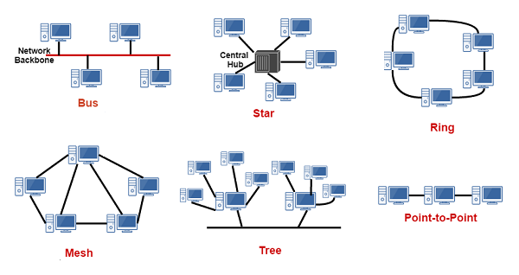

## **VPN Topology that Used to Create the System.**

* In this assessment, we have used the Full mesh VPN topology as it is the most mutual topology that has been used for wireless connections. And also, it gives a major benefit where it will work as same as before even if one of the connections fails. Since, this topology can convey information and data concurrently, it can handle a large amount of traffic also. Likewise, working with topology is easier where we can add additional devices if we need as it doesn’t harm or interrupt the data transmission within the devices. All the remote outlets can communicate with the Head office and the other remote locations without the need of routing through the Head office of the super market.

## **LAN Topology that Used to Create the System.**

* In this assessment we utilized Tree Topology as the Local Area Network (LAN) topology. Since this topology remains a blend on both, Bus topology and star topology. The fundamental purpose for the decision of choosing tree topology is that regardless of whether one center is harmed there is no impact to different outlets. It gives simple support and confirmation to the clients inside the LAN. This topology network is upheld by numerous equipment and programming merchants. The spine line ought to be secured and it ought to be kept in a spot where there are less odds of breaking the spine line.

# **Assumptions.**

Into the scenario the management said they have 120 outlets current and will be increase to 200 in the long run. So, we have taken 120 outlets are number of outlets of the super market chain. In the reginal level 10 storage and logistic center’s covering the Island. The head office which coordinate and provide all central support.

## **03.1 Supermarket Head Office.**

The Head Office executes all the huge activities inside the market chain where they screen all the activities of the remote outlets and Regional Stores .In Head Office there are some special sections such as Server Room , Control Room, Operational Room , Staff Room Inside the Server Room there are a few allotments where they are as per the following;

* DNS/DHCP.
* Web Server.
* Application Server.
* ERP & File Server.
* CCTV Server.
* IP PABX

The sum of the servers is related with the Server Farm Switch and it is then connected with the PF Sense Firewall to ensure that the packages are secured.

We put a Private Branch Exchange (PBX) inside the Server Room as it is an essential contraption to the entire Supermarket chain. This device has the limit of changing over the signs obtained by the VOIP phones into a media where they can bestow with no issue. At the point when this device is encouraged in the Head Office there is no need of placing this contraption in each remote region as they are related through Layer 2 VPN.

There is an Operational Room inside the Head Office where they control all the exercises of the Building Management System, central VOIP, Online Services and also control all the Enterprise Resource Planning and the Customers Relationship Management (CRM). So, we decided to set the following devices;

* + Computer.
  + Voice Over IP Phone.
  + Wireless Access Point
  + CCTV.
  + Computer.

There is a Central Control Room inside the Head Office as they need to screen all the CCTV in all shops, monitoring the transportation exercises and reginal distribution locations on security situations. We have chosen to put the accompanying gadgets;

* + NVR
  + UPS to give backup power to the NVR.
  + CCTV

There is a staff room where all the staff individuals from the Head Office can work together and talk with the regulatory focus concerning the activities. Along these lines, we decided to place the going with in the Staff Room;

* + CCTV.
  + Voice Over IP phone.

There is a Disaster Recovery Site (DR) related with the ISP, discovered away from the regulatory focus. On the off chance that there ought to emerge an event of a catastrophe, they can recover their data quickly from the support servers.

The Internet Service Provider (ISP) has the Website and the Front completion of the webpage, Email server and keep up a secured relationship with the bank.

Dialog is our ISP’s that we going to use for the supermarket chain.

## **03.2 Supermarket Outlet.**

We pondered that there are a few fragments in an outlet, which joins the reason for Sales zone, Store Room, Building and Power Management Room, Staff room and a control Box (Box Mount on the wall). The principal assignments done at the Point of Sales zone are offering things to the customers. Along these lines, we decided to place the going with in the Point of Sales region;

* + POS Machine for the cashier
  + Public Wi-Fi Router for the customers.
  + VOIP phone
  + CCTV

For the most part in each market outlet they have a store space to have a supply of their products, so we chose to put the accompanying in the Store region This is a restricted area. There’s an Entrance Biometric Guard Control for the users. (especially the fingerprint identification technology)

* + CCTV
  + Access Controlled Door with Biometric Fingerprint Scanner (Only for Staff).

There’ a Building and Power Management Room in the Outlet where the Controlling of lights, generators, atmosphere control frameworks, etc. Along these lines, we decided to place the going with in the Building and Power Management Room;

* + Computers where IT officers work.
  + CCTV.
  + VOIP Phone.

There is a staff room where all the staff individuals can collaborate together and speak with the administrative center in regards to the activities. There’s a Entrance Biometric Guard Control for the users. (especially the fingerprint identification technology)

In this way, we chose to put the accompanying in the Staff Room;

* + Computers.
  + CCTV.
  + VOIP Phone.
  + Biometrics Scanner (Authorized Persons Only).

There is a Power Management Room in this market outlet. They screen the power use and the fuel levels of the general store. Thusly, we decided to place the going with in the Power Management Room;

* + Computers.
  + CCTV.
  + Access Controlled Door.

We decided to place a Control Box within the Supermarket, where it consists of the Following;

* Router which is connected to the ISP, where it is connected to the head Office via a Layer 2 VPN, so that all the remote locations can interact and communicate with the Head office without any difficulty. It is then connected to a PF Sense Firewall to ensure that the data packets are being filtered and then connected to the Core Switch.
* Core Switch which is used to connect to Router switch which gives connection to the Access switches and the POE switches which gives connection to the devices.
* The Network Video Recorder (NVR) which has a built in Wi-Fi Adapter, is connected to the POE switch so that all the CCTV footages would be stored in it. We have setup a method of deleting the CCTV footages within two weeks’ time so that there won’t be any storage issue. Since there is a built in Wi-Fi Adapter inside the NVR there is no need to provide it a Static IP Address.
* UPS to give Backup power to the NVR & CCTV.

## **03.3 Supermarket Regional Centre.**

Around there we acknowledge that their items are taken care of. We acknowledged that there may be an individual or two to control the activities inside the distribution center, for instance, watching the stock, etc. We acknowledged that the transportation Vehicle Driver has a controlled access to the site in order to get the items or pass on the product beginning with one zone then onto the following. So, we used the resulting devices;

* + Computer.
  + CCTV.
  + Voice Over IP Phone.
  + Access Controlled Door.
  + NVR with backup UPS.

In to the scenario the management said they have 120 outlets current and will be increase to 200 in the long run. So, we have taken 120 outlets are number of outlets of the super market chain. In the reginal level 10 storage and logistic canter’s covering the Island. The head office which coordinate and provide all central support.

# **Plan of The Network.**

All in all terms, the Network Planning approach address the issue of given an area to be given availability utilizing a lot of hubs, decide the base price position topology, thinking about the equipment, the receiving wire type and direction, and radio broadcast powers, with the end goal that the agreement between force, obstacle, and implementation are satisfied.

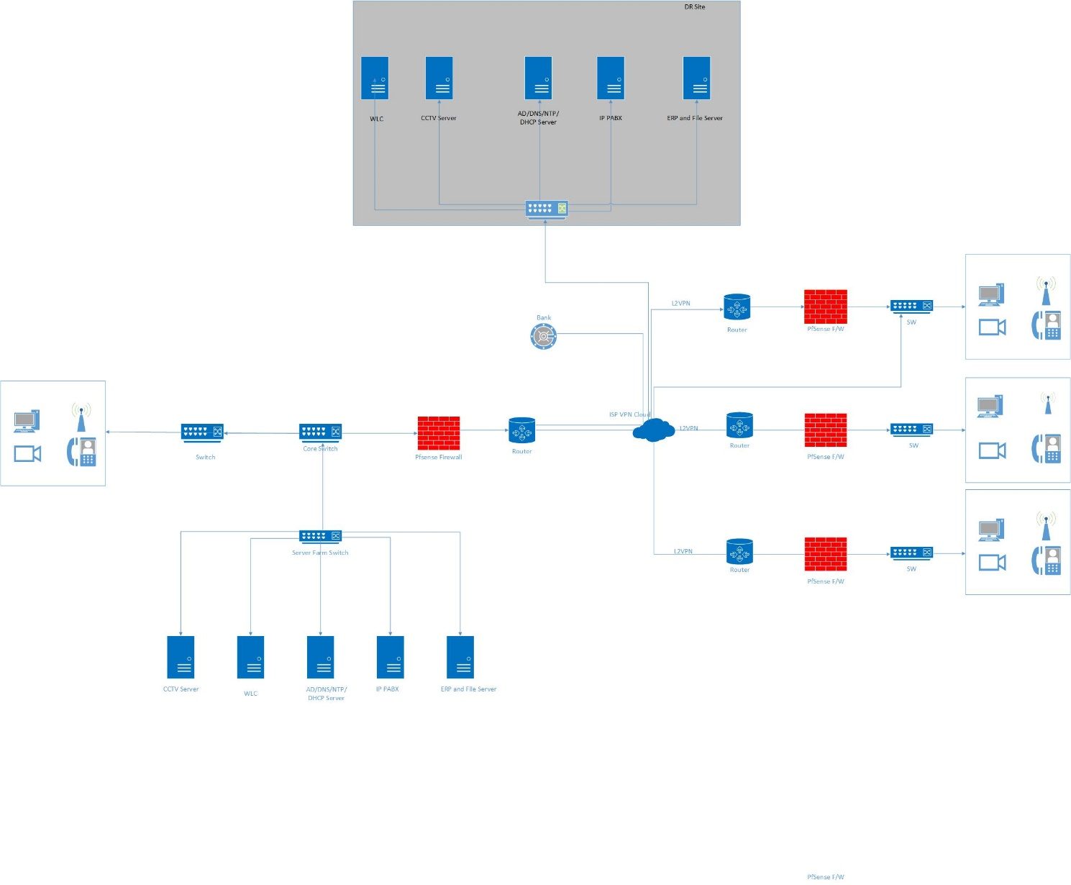

## **Physical Diagram of Head Office.**

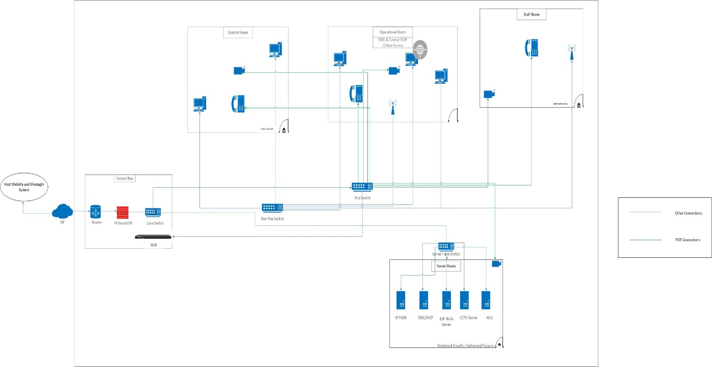

## **Logical Diagram of Head Office.**

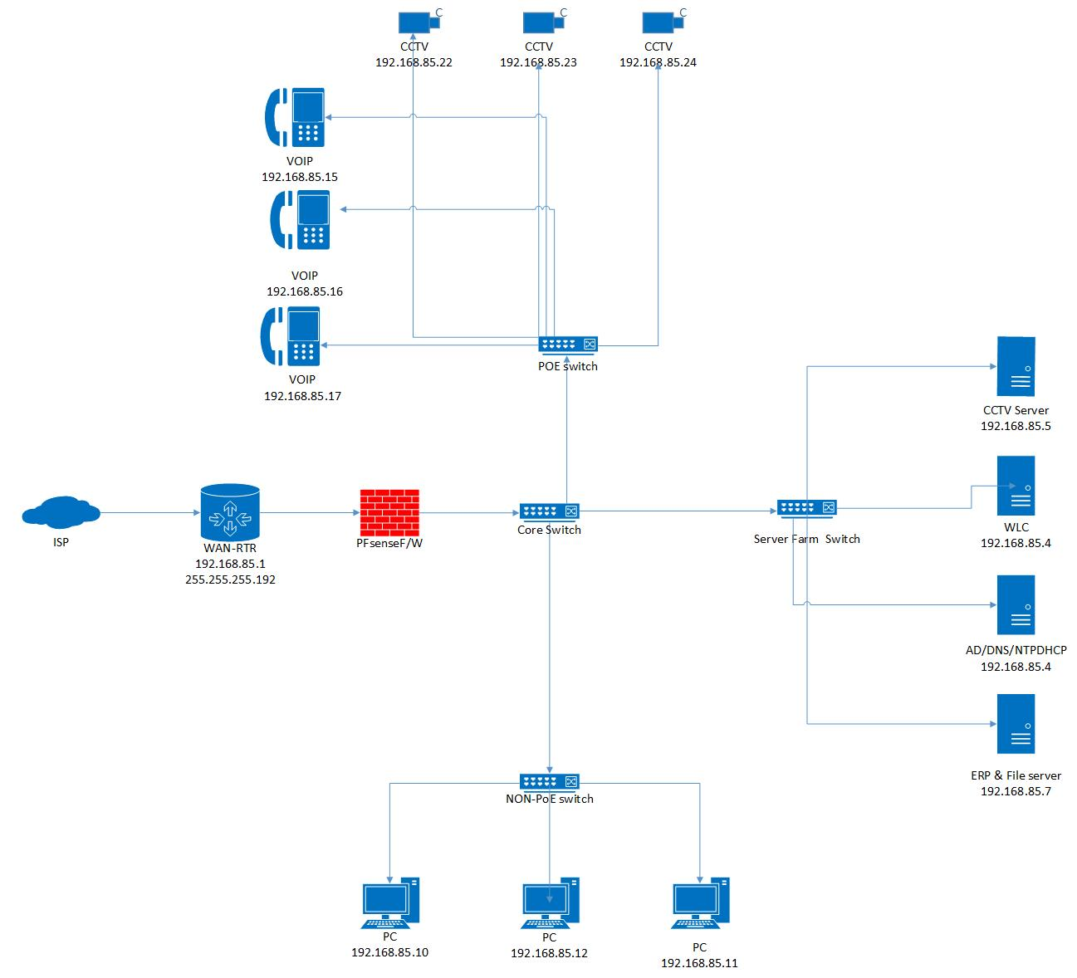

**Network IP range**

* 192.168.85.1 – 192.168.85.62

**Subnet mask**

* 255.255.255.192

## **Physical Diagram of Outlet.**

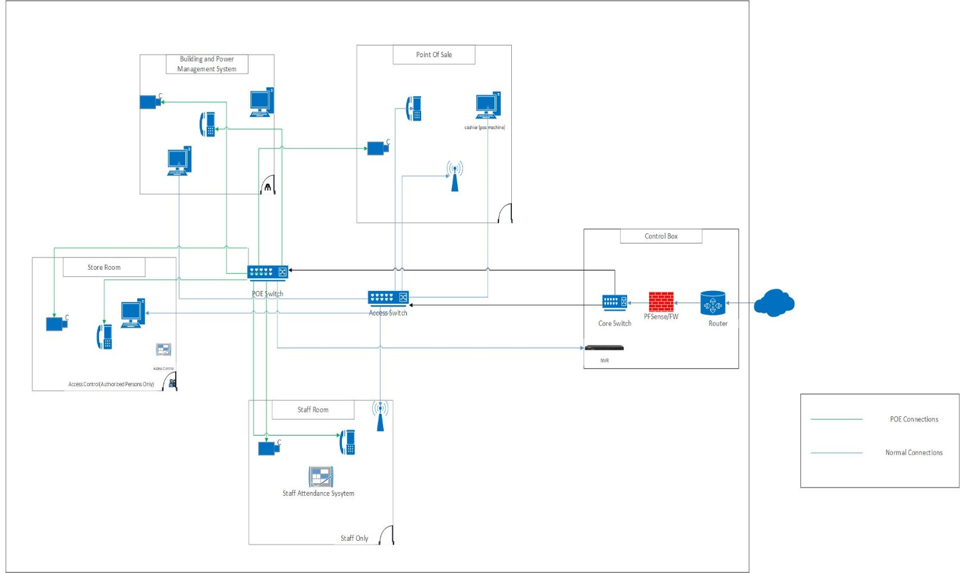

## **Logical Diagram of Outlet.**

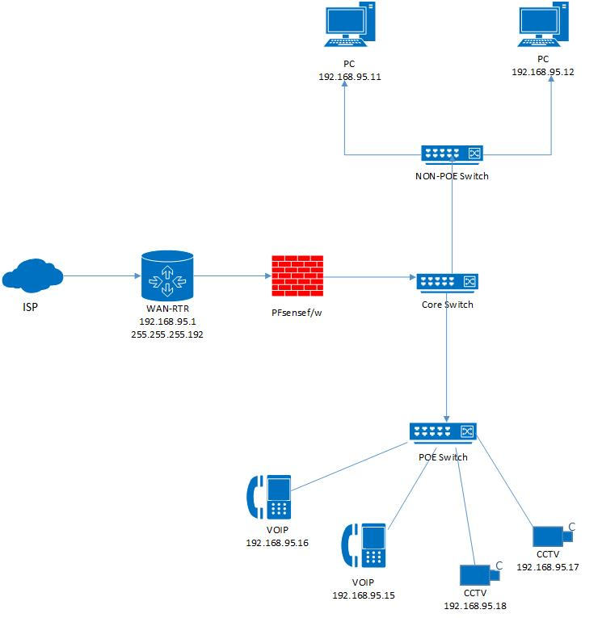

**Network IP range**

* 192.168.95.1 – 192.168.95.62

**Subnet mask**

* 255.255.255.192

## **Physical Diagram of Reginal Distribution Centre.**

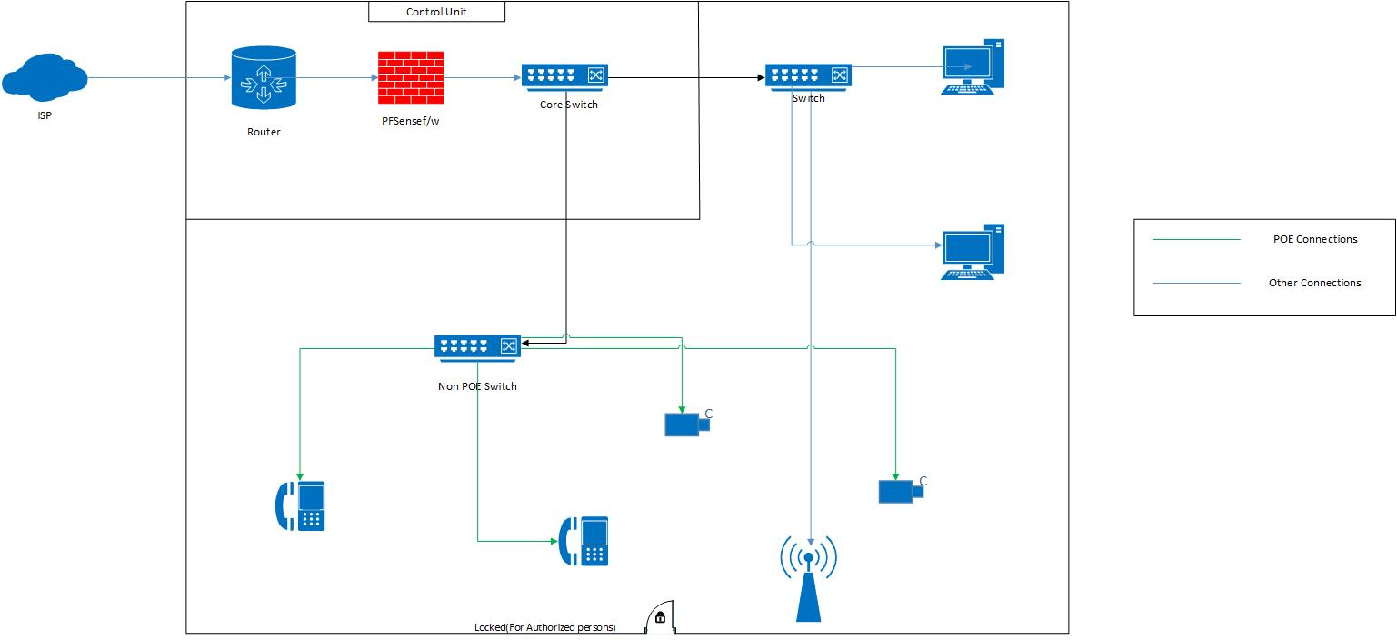

## **Logical Diagram of Reginal Distribution Centre.**

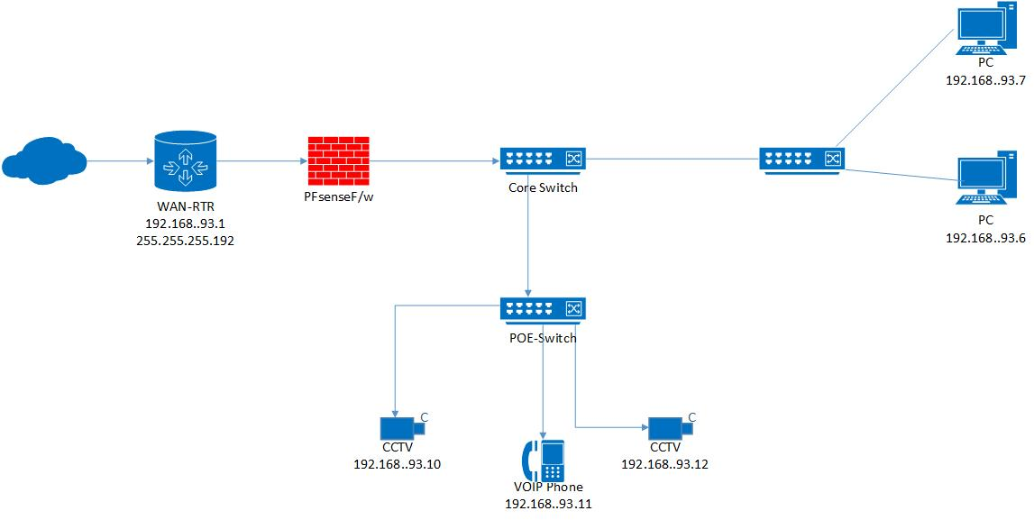

**Network IP Range**

* 192.168.93.1 – 192.168.93.62

**Subnet mask**

* 255.255.255.192

## **Packet Tracer Implementation of Outlet.**

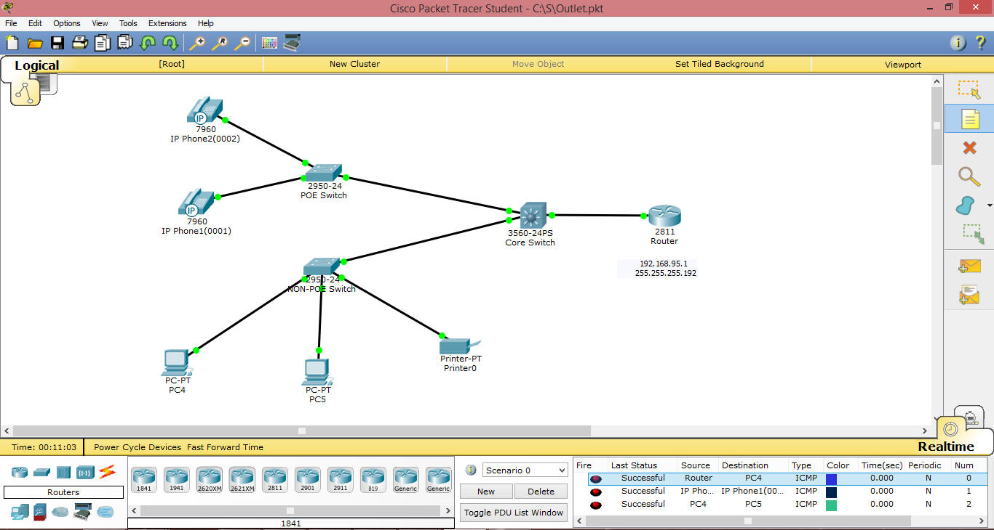

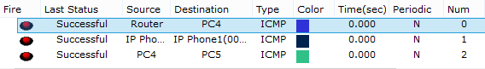

# **Equipment for The Network.**

## **Primary Option.**

**Head Office.**

|  |
| --- |
| **Router (Cisco):** Rv345P Dual Wan Gigabit VPN Router.  **Switch**   * Access Switches**:** Catalyst 2960-L with 48 ports (POE). * L3 Switch**:** C9500-12Q-A. * Server Farm Switch**:** Cisco SG350X-48P-K9-NA Managed 48 Port.   **WLC Wireless Controller**: Air-CT2504-5-K9 2504.  **Firewall Server:** PF Sense.  **CCTV NVR**: Safe Access Control System.  **PABX**: SPA525G2 IP Speakerphone.  **Servers**: Dell PowerEdge T630 E5-2603. |

* All the Routers, Switches, Controllers & NVR are cisco brand that we suggest to take.

**Super Market Outlet**

|  |
| --- |
| **Edge Router:** Ubiquiti ER-6P Edge Router 6-Port with PoE.  **Firewall:** PF Sense.  **Switch:** POE SG250X-24P-K9-EU - SG250X-24P 24-Port.  Non-POE SF 200 with 24 Ports Smart Switch. |

**Disaster Recovery.**

It provides by ISP.

* WAN Router.
* F/W Server.
* Farm Switch.

## **Secondary Option.**

**Head Office.**

|  |
| --- |
| **Routers:** Safe Stream Multi WAN Rackmount TP link Vpn Router.  **Switch**   * Access switches: Huawei S570 series 48 ports (POE). * Distribution switches: Huawei 24 Ports S5700-28P-LI-24S-BAT. * Core switch: Huawei E9000 Blade.   **Firewall:** Jupiter Networks cSRX Container Firewall.  **WLX Controller**: Huawei AC6605-26PWR-16AP.  **CCTV & Access control:** Asme Remote Focus and Zoom Pro Dome Network Cam.  Ezcome Secure Access Control System 6.  **Server:** Dell PowerEdge T430 E5-2603. |

**Super Market Outlet**

|  |
| --- |
| **Edge Router:** HP HSR6602-XG Router.  **Switch:** Huawei E9000 Blade 24 Ports POE.  Non-POE Hikvision DS-3E0524-E Unmanaged Switch 24 Ports.  **Firewall: SonicWall TZ400 Safety Firewall.** |

**Disaster Recovery.**

It provides by ISP.

* WAN Router.
* F/W Server.
* Farm Switch.

# **Specification of Equipment that Used.**

1. **Rv345P Dual Virtual Privet Network (WAN).**

* Load balance with 2 Wan Ports.
* High performance connectivity with 8 ports.
* 4G Modem or flash drive support with 2 Ports.

1. **PF-Sense Firewall Server.**

* “CPU 600 MHz
* Quicker.
* Smash 512 MB.
* 4 GB or bigger plate drive.
* At least one good system interface cards.
* Usb bootable drive or CD/DVD ROM for starting establishment.”

1. **Cisco C9500-12Q-A Core Switch with 24 Ports.**

* “Platinum-appraised AC/DC power supplies.
* Intel 2.4 GHz x86 CPU with up to 120 GB.
* Up to 6.4 Tbsp.
* Switching limit with up to 2 BPS of sending execution.
* Up to 32 nonblocking 100 Gigabit Ethernet QSFP28 ports.”

1. **Cisco SG350X-48P-K9-NA Managed server Farm Switch with 48 Ports.**

* “Cisco 350X Sequence switches are proposed to guarantee your advancement adventure as your business creates.
* Not in any manner like changes that assurance to be stackable anyway have parts that require separate association and exploring, the Cisco 350X Series gives certified stacking capacity.

1. **POE 48 ports Catalyst.**

* “Eight, Sixteen, Thirty-two GB information or else POE ports with line rate sending.
* Interminable POE backing through a force financial plan of max in 370W.
* Upgraded adaptation cisco lite programming.
* CLIN or potentially natural Web User Interface sensibility choices.
* Minimal structure through a profundity of under 11 ½ inch.

1. **Non-POE SF200-24 Ethernet Smart Switch with 24 Ports.**

* “24 x Fast Ethernet Ports.
* 2x Combo Mini GBIC Ports.
* 8.8 Switching Capacity.
* Supports up 256 VLANs.”

1. **Wireless controller Air 5304CT.**

* Online: “HTTP/HTTPS” singular gadget administrator.
* Order line interface: Telnet, SSH, sequential port.

1. **Secure Access Control System CCTV NVR.**

* Superb picture quality; select norm or HDTV quality.
* Accessible.
* Select the carefully designed, vandal safe or outside prepared models.

1. **SPA525G2 IP Speakerphone IP PABX.**

* “Graphics rich, high resolution 3.2-inch QVGA 320 x 240 Color screen.
* Cisco AnyConnect VPN Client: Highly secure Internet phone connection for remote users that is simple and easy to set up.
* Support for both Session Initiation Protocol.”

1. **Dell PowerEdge T430 E5-2603 Server.**

* “No working framework.
* RDIMM, 4GB, Single Rank, 8x Data Width.
* Hard Drive 1TB.”

1. **Ubiquiti ER-6P Edge Router with 6 Port.**

* “Gigabit Ethernet Ports.
* Ethernet Ports Support PoE.
* RJ 45 Serial Port.”

1. **POE SG250X-24P-K9-EU SG250X with 24 Port.**

* With SG250X-24P Smart Switches, you can accomplish business-class arrange execution and security without paying for cutting edge organize highlights that you won't use.

1. **Non-POE SF200-24 with 24 Port Ethernet Smart Switch.**

* “Cisco 200 Series Switches are a progression of reasonable brilliant switches that consolidate ground-breaking system execution and dependability with the fundamental system the board highlights your requirement for a strong business arrange.”

# **Network Plan of the Super Market.**

## **Head Office.**

|  |  |
| --- | --- |
| **Primary Option** | **Secondary Option** |
| 1x Rv345P Dual WAN Vpn Router.  4x PF-Sense Firewall Server.  1x Cisco C9500-12Q-A Core Switch with 24 Ports.  1x Cisco SG350X-48P-K9-NA Managed server Farm Switch with 48 Ports.  1x POE 48 ports Cisco Cristal.  1x Non-POE SF200-24 Ethernet Smart Switch with 24 Ports.  3x Air-CT2504-5-K9 2504 WLC Wireless controller.  1x Safe Access Control System CCTV NVR.  1x SPA525G2 IP Speakerphone PABX.  5x Dell PowerEdge T430 E5 2603 Server. | 1x Stream Multi WAN Rackmount Tp link Vpn Router.  4x Jupiter Net cSRX Container Firewall.  1x HUAWEI E9000 BLADE with 24 Ports.  1x KX TDA100BS IP PBX Panasonic.  5x DELL POWEREDGE T430 E5-2603.  1x Huawei S5700-28P Server Farm with 24 Ports.  1x Huawei S570 series 48 ports (POE).  3x Huawei AC6605-26PWR-16AP WLC.  1x Ezcome Safe Entree Switch System 6. |

## **Super Market Outlet.**

|  |  |
| --- | --- |
| **Primary Option** | **Secondary Option** |
| 120x Ubiquiti ER-6P Edge Router with 6 Port with PoE.  240x PF-Sense Firewalls.  1x Cisco C9500-12Q-A Core Switch with 24 Ports.  120x Non-POE SF200-24 with 24 Port Ethernet Smart Switch. | 120x Ubiquiti ER-6P Edge Router with 6 Port with PoE.  240x PF-Sense Firewalls.  120x POE SG250X-24P-K9-EU - SG250X-24P with 24 Port.  120x Non-POE SF200-24 with 24 Port Ethernet Smart Switch. |

## **Reginal Distribution Centre.**

|  |  |
| --- | --- |
| **Primary Option** | **Secondary Option** |
| 1x Rv345P Dual WAN Vpn Router.  1x Cisco C9500-12Q-A Core Switch with 24 Ports.  1x Cisco C9500-12Q-A Core Switch with 24 Ports.  5x Secure Access Control System CCTV.  1x NVR.  2x SPA525G2 IP Speakerphone IP. | 1x Stream Multi WAN Rackmount Tp link Vpn Router.  1x HUAWEI E9000 BLADE with 24 Ports.  1x Huawei S570 series 48 ports.  5x Ezcome Secure Access Control System.  2x KX TDA100BS IP Panasonic.  1x Ezcome Secure Access Control System. |

# **Internet Protocol Address.**

Any Computer, Mobile phone whatever machine that you get it has a network code to identify. If would you like to address a letter to send in to another party by using the mail, computers are use that unique identifier to send packet data to select computers that are on the network. Maximum networks nowadays, include all the machines connect on the internet, by using IP protocol as the typical for how to connect on the network. In the TCP or IP protocol, is the unique identifier for a computer are named its IP address.

There are two types of IP address:

* + Internet Protocol Version 4 (IP_v4).
  + Internet Protocol Version 6 (IP_v6).

In all machines had with IP addresses have an IPv4 address, and many are starting to use the new IPv6 address as well.

After studying IP address, we are decided to IP addressing, we need to know several things. Initially, there are 5 classes of IP’s that choices from class A to E.

* **Class A:** In here this is a private set of addresses that can be connected inside an organization. It can be identified by the network 10.0.0.0 /8.
* **Class B**: In here this class can be known because it starts from 172.16.0.0 /12 to 172.31.255.255.
* **Class C:** In this class can be known by seeing the addresses from 192.168.0.0 /16 to 223.255.254.254.
* **Class D**: In this class addresses of class D starts from 224.0.0.0 to 239.255.255.255.
* **Class E:** the final class E is and experimental class of IP’s which we can’t ger access to.

Not only that but also if we are going to connect all our machines to a network, we can only use class B or class C. Although, technically we could use class A addresses, we can’t connect them directly to the internet because class A addresses are used to connect devices inside an organization. Not only, but the whole class of IPs starting from 127. Cannot be entered to anything because it is used for local loopback testing.

When analyzing these facts In This case we used Class A for IP addressing,

Then we are after carefully considering all these things, we are going to set up the IP addresses for this supermarket chain network by using IP addresses from Class C.

# **Subnet.**

Subnetting is fundamentally only a method of parting a TCP/IP arrange into littler, increasingly reasonable pieces. The essential thought is that in the event that we have an over the top measure of traffic streaming over this network, at that point that traffic can make our network run gradually. At the point when we subnet our network, you are parting the network into a different, however interconnected network. That way, the greater part of the network traffic will be secluded to the subnet in which it began. Obviously, we can at present impart over a subnet, yet the main time that traffic will cross subnet limits is the point at which it is explicitly bound for a host living in a substitute subnet. In This Case we use Class c for IP address. Assume for instance We expected to split subnets with 40-45 addresses to each. Since this is a class C address, the host identifier bit of the IP address takes up 8 bits. In the event that we need to subnet this address block, we should acquire a portion of the bits that are utilized for the host identifier and use them for the network identifier.

**Subnet Mask**

Subnet mask is a number that describes a scope of IP watches out for that can be used in a system. A subnet mask stows away, or "mask" the system part of a structure's IP address and leaves only the host part as the machine identifier.

An average subnet veil for a Class C IP address is 255.255. 255.0.

# **Bill of Materials.**

## **Primary Option.**

|  |  |  |  |
| --- | --- | --- | --- |
| **Items** | **Quantity** | **Per Cost of Item** | **Total** |
| Rv345P Dual WAN Vpn Router. | 1 | $600 | $600 |
| PF-Sense Firewall Server. | 4 | $200 | $800 |
| Cisco C9500-12Q-A Core Switch with 24 Ports. | 1 | $1500 | $1500 |
| Cisco SG350X-48P-K9-NA Managed server Farm Switch with 48 Ports. | 1 | $1700 | $1700 |
| POE 48 ports Cisco Cristal. | 1 | $1000 | $1000 |
| Non-POE SF200-24 Ethernet Smart Switch with 24 Ports. | 1 | $7000 | $7000 |
| Air-CT2504-5-K9 2504 WLC Wireless controller. | 3 | $1200 | $3600 |
| Safe Access Control System CCTV NVR. | 1 | $400 | $400 |
| SPA525G2 IP Speakerphone PABX. | 1 | $13,000 | $13,000 |
| Dell PowerEdge T430 E5 2603 Server. | 5 | $2000 | $10,000 |

## **Secondary Option.**

|  |  |  |  |
| --- | --- | --- | --- |
| **Items** | **Quantity** | **Per Cost of Item** | **Total** |
| Multi WAN Rackmount Tp link Vpn Router. | 1 | $1000 | $1000 |
| HUAWEI E9000 BLADE with 24 Ports. | 1 | $10,000 | $10,000 |
| Huawei S570 series 48 ports (POE). | 1 | $2500 | $2500 |
| Huawei S5700-28P Server Farm Switch. | 1 | $2000 | $2000 |
| Jupiter Net cSRX Container Firewall. | 4 | $500 | $20,000 |
| Huawei AC6605-26PWR-16AP WLC. | 2 | $1000 | $2000 |
| KX TDA100BS IP PBX Panasonic. | 1 | $15,000 | $15,000 |
| Ezcome Safe Entree Switch System. | 1 | $1000 | $1000 |
| DELL POWEREDGE T430 E5-2603. | 5 | $3000 | $15,000 |

1. **Grand Total for Primary Option: $ 35,700.00 (Head Office Only).**
2. **Grand Total for Secondary Option: $ 50,500.00 (Head Office Only).**

# **Reference.**

1. Online drawing tool - <https://www.draw.io>
2. Ezcome Equipment’s details - <http://www.ezcomsecurity.com>
3. Cisco Equipment’s details - <https://www.cisco.com/c/en/us/products>
4. Juniper Equipment’s details - <https://www.juniper.net>
5. Engeniustech Equipment’s details - <https://www.engeniustech.com>
6. TP-Link Equipment’s details - <https://www.tp-link.com>

1. Prices of Network Equipment’s - <https://www.router-switch.com>
2. Huawei Equipment’s details - <https://e.huawei.com>
3. IP addressing’ s details - <https://computer.howstuffworks.com/what-is-an-ip-address.htm>